**ArcFace: Additive Angular Margin Loss for Deep Face Recognition - Report**

The paper introduces a new loss function called ArcFace, which enhances the discriminative power of deep neural networks for face recognition.

The authors propose an angular margin-based approach that not only improves class separability but also provides a clear geometric interpretation.

**Introduction**

Face recognition is a fundamental task in computer vision, with applications ranging from security to social media tagging. Traditional softmax-based loss functions have limitations in considering more low level details and perfoming well in multiple different classes. The ArcFace loss aims to address these issues by introducing an angular margin term.

The ArcFace loss is designed to learn highly discriminative feature embeddings for face images.

**Geometric Interpretation**

* ArcFace operates on a hypersphere, where each class corresponds to a point on the sphere’s surface.
* The angle between the feature vector and the class center (represented as a normalized weight vector) is crucial.
* The loss encourages the feature vectors to move closer to their corresponding class centers while maintaining a margin between different classes.

**Theoritical Formula**

Given an input face image with feature vector **x** and its ground truth class label **y**, the ArcFace loss is defined as:

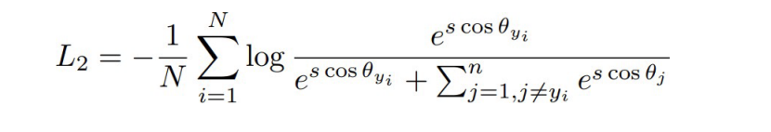

* **N**: Number of training samples
* **s**: Scaling factor (hyperparameter)
* **θ**: Angle between **x** and class center weight vectors

**The Upgraded Formula with Margin**

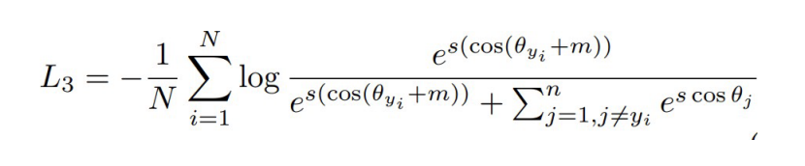

* The angular margin term ensures that the feature vectors are pushed away from the decision boundary.
* It enforces a minimum angular separation between the correct class and other classes.
* The margin is adaptive and depends on the intra-class variations.

**Technique to handle Label Noises:**

To handle label noise and variations within classes, the authors propose sub-center ArcFace:

* Each class has K sub-centers, representing different variations.
* Training samples should be close to any of the K positive sub-centers.
* Encourages a dominant sub-class with clean faces and non-dominant sub-classes containing hard or noisy faces.

**Synthesising Face Images**

The pre-trained ArcFace model can generate identity-preserved face images which can be useful for data augmentation and improving model robustness.

**Conclusion**

ArcFace enhances both discriminative feature embedding and generative face synthesis. It provides a powerful tool for improving face recognition systems, especially in scenarios with large intra-class variations.

In conclusion, ArcFace bridges the gap between geometric intuition and deep learning, making it a valuable addition to the face recognition solutions.

**References:**

ArcLoss Function

https://github.com/deepinsight/insightface/blob/master/recognition/arcface_torch/losses.py

Understanding Code in Paper:

https://github.com/deepinsight/insightface/tree/master

CIFAR 10 Classification:

https://github.com/NvsYashwanth/CIFAR-10-Image-Classification

Understanding CIFAR-10 dataset:

https://www.kaggle.com/c/cifar-10/

MNIST Classification:

https://ashleyycz.medium.com/mnist-digit-classification-in-pytorch-302476b34e4f

Understanding MNIST Dataset:

https://www.kaggle.com/datasets/hojjatk/mnist-dataset